**First we will create a table without using bootstrap ↓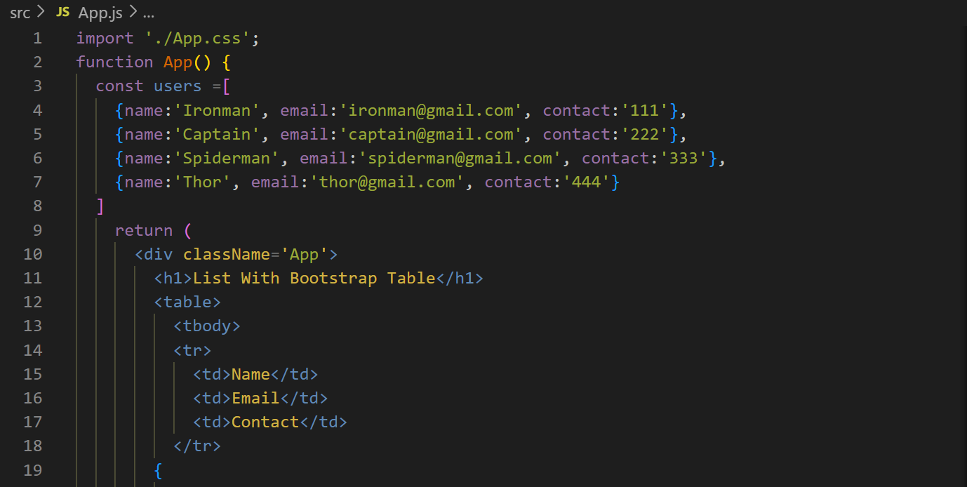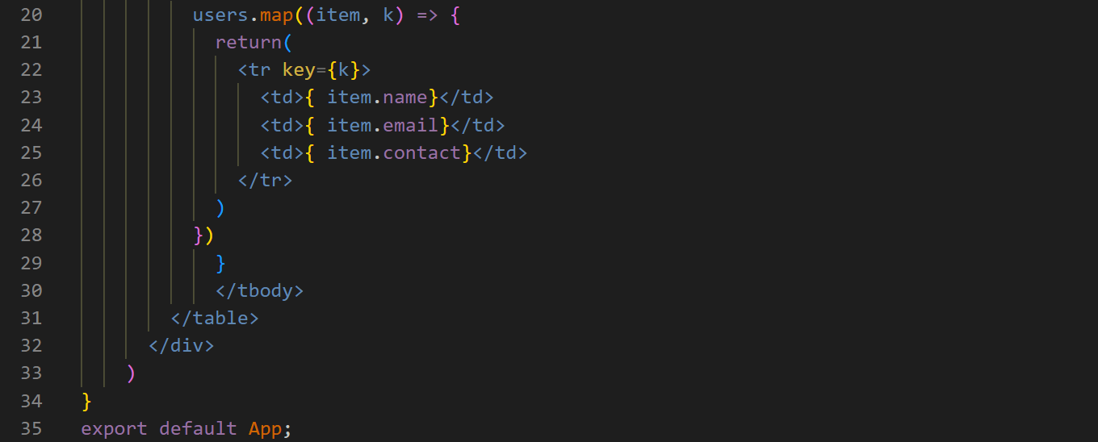output ↓**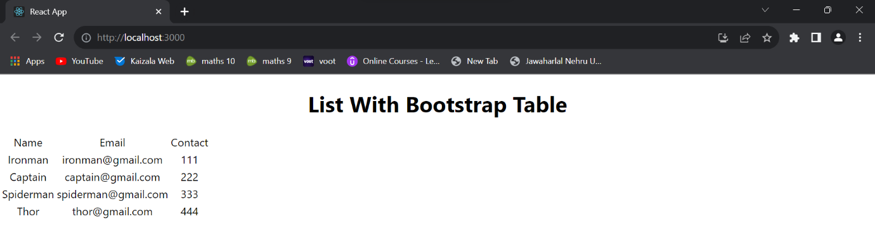

**With bootstrap ↓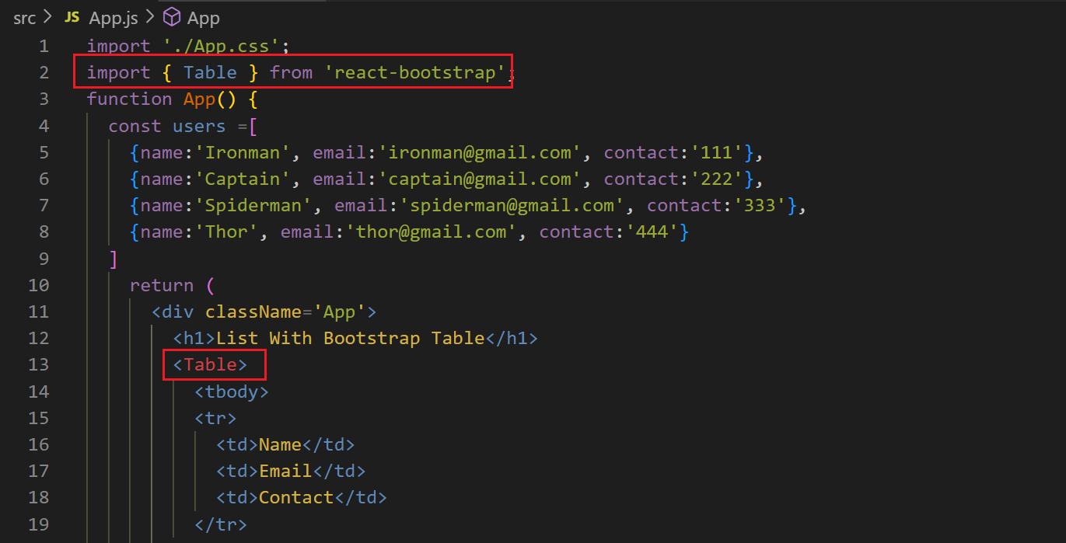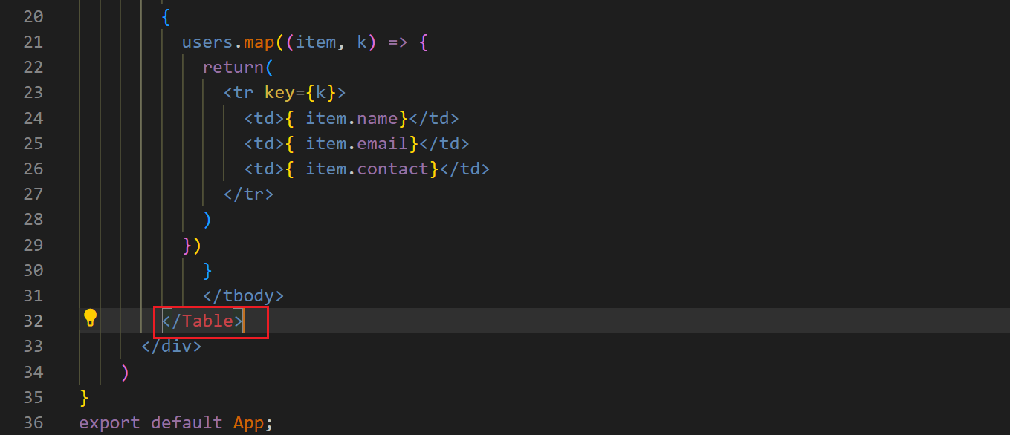output ↓**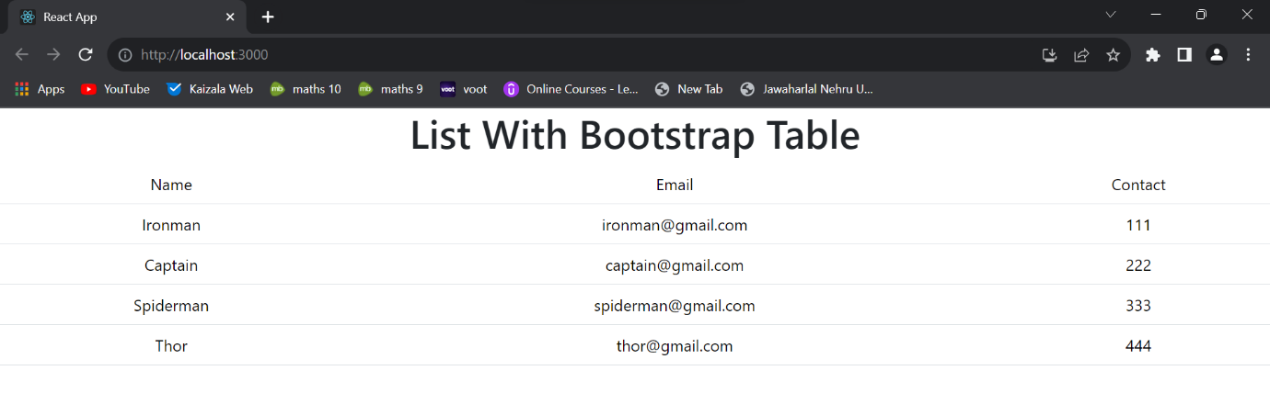

**You can pick table properties from bootstrap website and apply them in your table, e.g., ↓output ↓**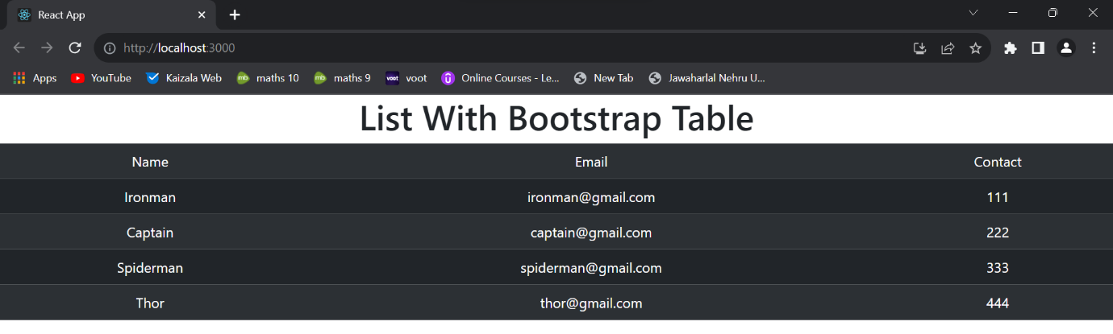

**We can use conditions ↓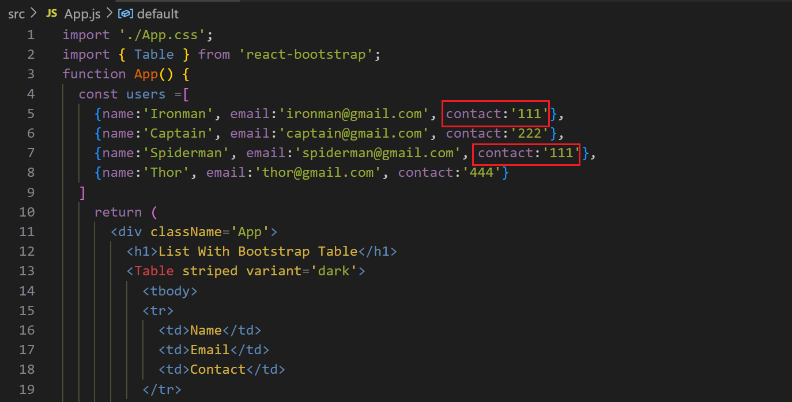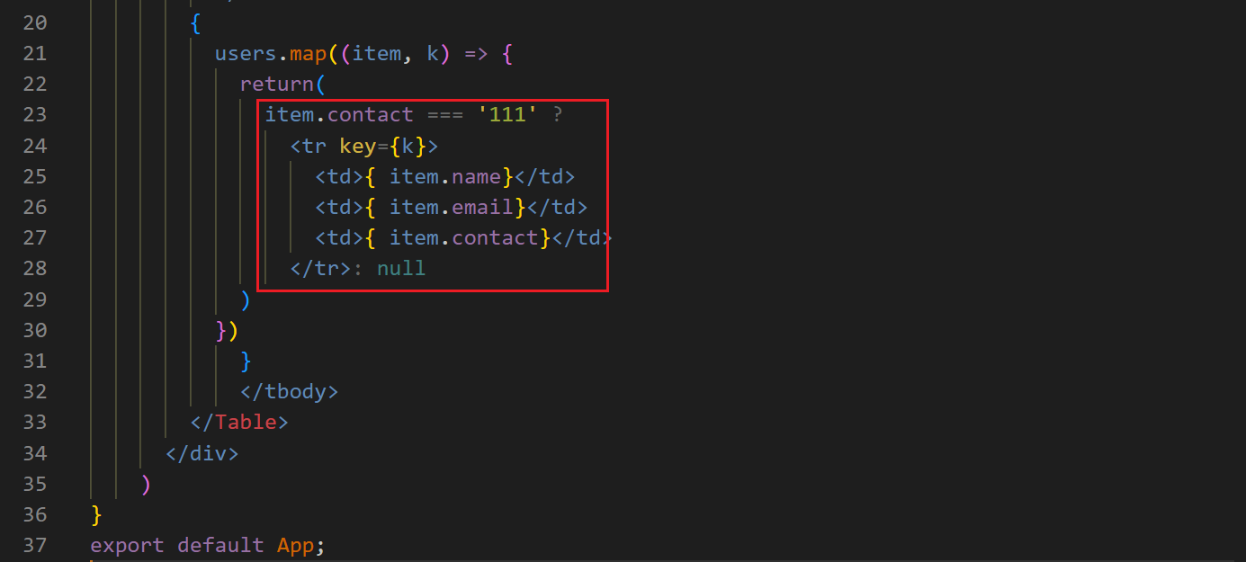output ↓**